A+ Computer Science Labyrinth Island – Kyle Devereaux Lab Value - 100

Lab Goal: To create a problem that incorporates the various commands and loops the class has learned in the Jeroo Unit. Programming that is required to be included are methods, “while” loops, “if”, “else”, and “else if” statements. Along with these statements Boolean values which are used in the statements as conditionals. Basic commands that are unique to Jeroo also are include in the lab such as “pick();”, “toss();”, and “hop();”.
Lab Description: This lab requires an assortment of conditional commands and loops to navigate the labyrinth in order to reach the end. Along the way, all flowers in the labyrinth are required to be collected. There are three blockades in the labyrinth that you void using flowers. You may not use the flowers to void any nets except for the blockade nets. At the end of the labyrinth, it is required to build a box with the flowers you collected in the labyrinth and with the flowers you received as a post condition. When the box is completed, the Jeroo must stop. See the images below for a representation.
Files Needed:
labyrinth.jsc
labyrinthIsland.jev

Starting Screen:
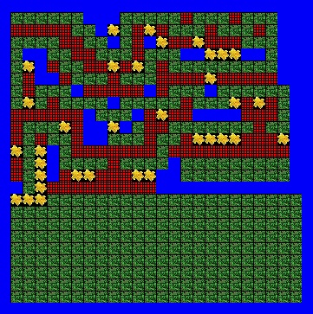
algorithm help

Preconditions -
- Jeroo is at (0, 0), facing East and has 31 flowers.
- Blockades appear at (5, 8), (9, 20) and (12, 8).
- The end of the labyrinth is at (14, 1).

Required Actions -
- All the flowers in the maze are collected.
- The blockades of the maze are gone using the toss(); command.
- The blockades are the only nets that are allowed to be voided with flowers.

Postcondition -
- Successful hop through the labyrinth (not in a net or water)
- A box at the bottom portion of the map is made out of the flowers you collected.

Ending Screen:
